**Magnetic refrigeration** is a cooling technology based on the **magnetocaloric effect**. This technique can be used to attain extremely low [temperatures](http://en.wikipedia.org/wiki/Temperature) (well below 1 [K](http://en.wikipedia.org/wiki/Kelvin)), as well as the ranges used in common [refrigerators](http://en.wikipedia.org/wiki/Refrigerator), depending on the design of the system.

The magnetocaloric effect (MCE, from [*magnet*](http://en.wikipedia.org/wiki/Magnet) and [*calorie*](http://en.wikipedia.org/wiki/Calorie)) is a magneto-[thermodynamic](http://en.wikipedia.org/wiki/Thermodynamic) phenomenon in which a reversible change in temperature of a suitable material is caused by exposing the material to a changing magnetic field. This is also known by low temperature physicists as [**adiabatic**](http://en.wikipedia.org/wiki/Adiabatic_process)**demagnetization**, due to the application of the process specifically to create a temperature drop. In that part of the overall refrigeration process, a decrease in the strength of an externally applied magnetic field allows the magnetic domains of a chosen (magnetocaloric) material to become disoriented from the magnetic field by the agitating action of the thermal energy ([phonons](http://en.wikipedia.org/wiki/Phonon)) present in the material. If the material is isolated so that no energy is allowed to (re)migrate into the material during this time, *i.e.*, an adiabatic process, the [temperature](http://en.wikipedia.org/wiki/Temperature) drops as the domains absorb the thermal energy to perform their reorientation. The randomization of the domains occurs in a similar fashion to the randomization at the [curie temperature](http://en.wikipedia.org/wiki/Curie_temperature), except that magnetic dipoles overcome a decreasing external magnetic field while energy remains constant, instead of magnetic domains being disrupted from internal[ferromagnetism](http://en.wikipedia.org/wiki/Ferromagnetism) as energy is added.

**Thermodynamic cycle**

[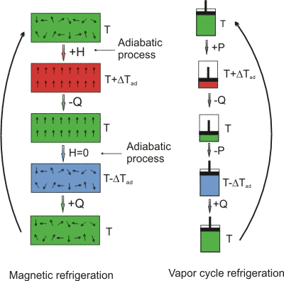](http://en.wikipedia.org/wiki/File:MCE.gif)

[http://bits.wikimedia.org/skins-1.17/common/images/magnify-clip.png](http://en.wikipedia.org/wiki/File:MCE.gif)

Analogy between magnetic refrigeration and vapor cycle or conventional refrigeration. *H* = externally applied magnetic field; *Q* = heat quantity; *P* = pressure; Δ*T*ad = adiabatic temperature variation

The cycle is performed as a [refrigeration cycle](http://en.wikipedia.org/wiki/Refrigeration_cycle), analogous to the [Carnot cycle](http://en.wikipedia.org/wiki/Carnot_cycle), and can be described at a starting point whereby the chosen working substance is introduced into a[magnetic field](http://en.wikipedia.org/wiki/Magnetic_field), *i.e.*, the magnetic flux density is increased. The working material is the refrigerant, and starts in thermal equilibrium with the refrigerated environment.

* **Adiabatic magnetization:** A magnetocaloric substance is placed in an insulated environment. The increasing external magnetic field (+*H*) causes the [magnetic dipoles](http://en.wikipedia.org/wiki/Magnetic_dipole) of the atoms to align, thereby decreasing the material's magnetic [entropy](http://en.wikipedia.org/wiki/Entropy) and [heat capacity](http://en.wikipedia.org/wiki/Heat_capacity). Since overall energy is not lost (yet) and therefore total [entropy](http://en.wikipedia.org/wiki/Entropy) is not reduced (according to thermodynamic laws), the net result is that the item heats up (*T* + Δ*T*ad).
* **Isomagnetic enthalpic transfer:** This added heat can then be removed (-*Q*) by a fluid or gas — gaseous or liquid [helium](http://en.wikipedia.org/wiki/Helium), for example. The magnetic field is held constant to prevent the dipoles from reabsorbing the heat. Once sufficiently cooled, the magnetocaloric substance and the coolant are separated (*H*=0).
* **Adiabatic demagnetization:** The substance is returned to another adiabatic (insulated) condition so the total entropy remains constant. However, this time the magnetic field is decreased, the thermal energy causes the magnetic moments to overcome the field, and thus the sample cools, *i.e.*, an adiabatic temperature change. Energy (and entropy) transfers from thermal entropy to magnetic entropy (disorder of the magnetic dipoles).
* **Isomagnetic entropic transfer:** The magnetic field is held constant to prevent the material from heating back up. The material is placed in thermal contact with the environment being refrigerated. Because the working material is cooler than the refrigerated environment (by design), heat energy migrates into the working material (+*Q*).

Once the refrigerant and refrigerated environment are in thermal equilibrium, the cycle begins again.